PURPOSE

NIHVA Technologies has made a “Strategic Business Decision” to develop and implement an effective Quality Management Systems (QMS) across all areas of the Company.

Implementation of the QMS as per ISO9001-2015 is intended to improve and sustain the overall performance of our business, products and services.

This manual is designed to support:
    - The ability to consistently provide products and services that meet customer and applicable Statutory and Regulatory requirements;
    - the ability to plan our processes and their interactions by employing the Plan-Do-Check-Act (PDCA) cycle and risk-based thinking in our daily operations;
    - the facilitating of opportunities to enhance customer satisfaction;
    - Addressing risks and opportunities associated with its context and objectives.

The QMS Manual is considered the normative basis of reference to the International Standard and shall be used internally to provide an overview of ISO 9001:2015 requirements and how they apply at NIHVA Technologies. The QMS Manual is used externally to introduce the elements of our QMS to our customers and other external organizations to the extent necessary.

SCOPE

    - Design, manufacturing and/or assembly, supply, installation - commissioning, servicing of material handling equipment (Scissor lift, dock leveller) and door automation (Gates, sliding roof and rolling shutters)

Manufacturing and/or Assembly, Supply, installation - commissioning and servicing of all other Door Automation, Automation Solution products and SPMs

The scope and intent of our QMS is to define and communicate our commitment to continually enhance customer satisfaction through:
    - effective process improvements to all systems of the business;
    - to assure conformity to our customer’s and applicable statutory and regulatory requirements;
    - provide policies, procedures developed and implemented with the primary focus to assure the continual compliance of the requirements of the International Standard ISO9001:2015

DETAILS

  - Quality Management Principles – NIHVA Technologies has adopted and realizes the benefits of Quality Management Principles into our daily activities. The intent of the Quality Management Principles is to provide a foundation to continually improve upon the Company’s performance. Subsequent sections of the QMS Manual will provide our commitments of the following QMP elements:
    - Customer focus;
    - leadership;
    - communications and the engagement of our people;
    - process approach;
    - improvement;
    - risk & opportunity as well as evidence-based decision making;
    - relationship management.

  - Process Approach – NIHVA Technologies has adopted the “Process Approach” into our daily operations including the PDCA Cycle. We have considered the utilization of Risk-Based Thinking Philosophy when developing, implementing, and improving the effectiveness of our Quality Management System. This approach will enable NIHVA Technologies to enhance the overall

performance of the Company by effectively controlling the interrelationships and the interdependencies among the QMS processes. The implementation of the “Process Approach” in our QMS enables;
    - the understanding and consistency with achieving customer specific requirements;
    - the consideration of our processes in terms of added value;
    - the achievement of effective process performance;
    - improvement of our processes based on the evaluation of data and information.

  - PDCA Cycle: Management of the processes and the system as a whole is achieved using PDCA cycle with an overall focus on risk-based thinking aimed at taking advantage of opportunities and preventing undesirable results. Following figure illustrates how all clauses can be grouped in relation to the PDCA Cycle. Number in bracket represent ISO9001-2015 clause.

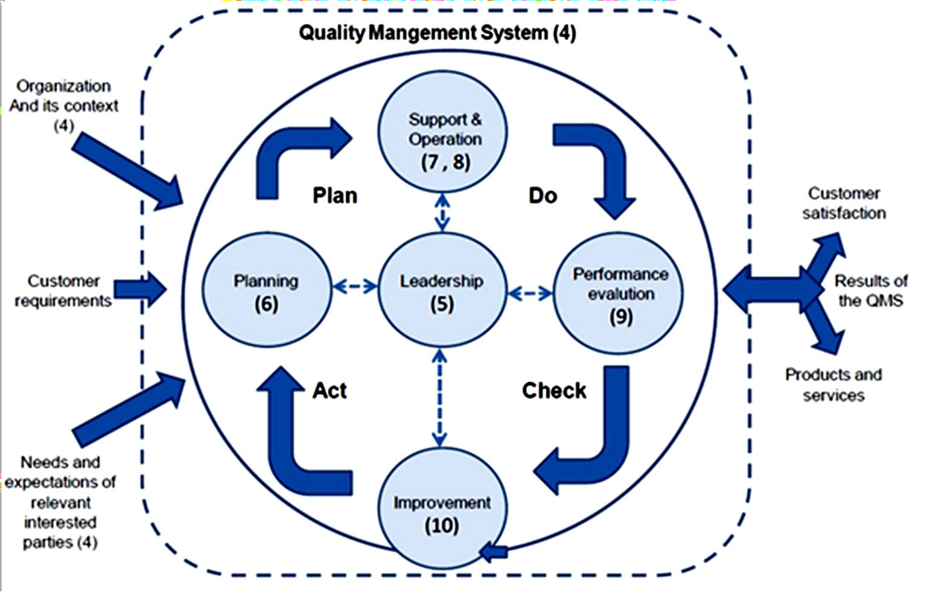

Risk Based thinking

    - NIHVA has adopted Risk-based thinking approach to enhance effectiveness of QMS, by planning and implementing actions to address risks and opportunities..
    - Opportunity can arise as a result of favorable situation to achieving an intended result, such as-
      - Circumstances that include new customer, new business, new product and services
      - Waste reduction
      - Productivity improvement, etc.
    - Actions to address opportunities can include consideration of associated risks
    - Positive deviation arising from risk also can provide an opportunity

